Champions of the Flyway, a Green Team from North Ronaldsay

The title alone makes one imagine an exciting mix of bizarre people, places and events and a busy scenario is exactly what it was. A team of four birders from North Ronaldsay, the northernmost island in the Orkney archipelago decided to join together and head for the deserts of Israel in order to participate in the Champions of the Flyway 2017 24 hour bird race! The feat was by no means a simple one. Our task was to see as many species of bird in a 24 hour period in Israel and raising as many funds as possible for BirdLife International in the lead up to the event. The donations we raised would go straight to help save migrant birds passing through Eastern Europe from illegal hunting and poaching.
Our team consisted of three North Ronaldsay Bird Observatory staff/volunteers (Erin Taylor, George Gay and Samuel Perfect) and our inspiration, Gary Prescott (aka the Biking Birder).
The Spokesfolks team in a nutshell:
Erin Taylor – A superb bird ringer and an excellent knowledge of aging and sexing species in the hand, now the Portland Bird Observatory assistant warden. With a first in her MSc and being a keen researcher, working with seabirds, particularly Storm Petrels is close to her heart.
Gary Prescott – 61 years young and has achieved great things most recently becoming the “green big year champion” in the UK, and Europe in his year-long adventure in 2016. Raising money for RSPB, WWT, Asthma UK and Chaskawasi-Manu, a project giving the children from the Manu rainforest in Peru the opportunity to go to school and get an education.
George Gay – Now a resident on North Ronaldsay, helping with croft work, volunteering at the bird observatory and an accomplished ringer. A dedicated Bristol City football supporter and great photographer with lots of birding experience under his belt.
Gavin Woodbridge – A new addition to the team, an expert ringer and resident on North Ronaldsay. As well as having found an impressive number of rarities he is dedicated to looking after and sheering many of the island’s native breed of sheep.
Samuel Perfect – Loves bird observatories in general and enjoys birding by bike. Very keen on seawatching and training towards a ringing permit. Has a BSc in environmental science and is keen to pursue a career that balances both interests.
We set off on 23rd March, arriving in a habitat totally new to us, desert! The heat hit us in the face as soon as we stepped outside, layers were removed and we began birding.
It was our ambition to compete in the event by “green” birding methods only, so in the week leading up to the race and during the race itself we found ourselves exploring southernmost Israel entirely by bike or foot. This proved to be immensely successful. Not only were we spending the entire day in the field, wasting no time sat in a car travelling between sites, but we also gained a greater appreciation of our surroundings. We familiarised ourselves with the endless supply of sights and sounds of the wildlife around us, including Bluethroats scuttling about in the crop fields, chancing upon stunning male Pallid Harriers, screeching to a halt to admire Little Green Bee-eaters, and Pied Kingfishers eking out a living beside the canal. Even indulging in some fruits growing beside the track, all of which could not have been as enjoyable from the back seat of a car.
We worked well together as a team, finding some quality species, taking some brilliant pictures and even getting a few opportunities to observe close up a few species in the hand (we felt like kids in a playground with something for everyone). Being on bikes also encouraged us to venture off-course, explore parts of the countryside ourselves and revel in our own personal highlights. However, a quick shout from any one of us and we’d all come running, as sharing the best birds with one another was the most rewarding experience. Gary was an immense inspiration and role model, striking up some brilliant friendships with other competitors, many of whom were renowned experts in their respective fields including field guide authors, conservationists, artists, event hosts and many more.
As previously mentioned, we competed in the event by bike and foot with the intention of minimising our carbon footprint. Given that this is particularly topical and that our excessive consumer habits are negatively impacting the very birds we enjoy to watch we felt it is only moral for us to appreciate them in a way that brings least harm to the environment. This method of birding tests physical, mental and level of commitment abilities and the huge feel-good factor that comes with this is testimony to really working to find and see birds.
Without any prior knowledge of Eilat and with a sense of sweet naivety over what we would face we succeeded against all odds in winning, despite competing with some very well drilled local birdwatchers, and claimed the prize as Green Champions for COTF 2017! This is something that we are hugely proud of and this is definitely a title we would like to defend in 2019. As with all teams, we are imploring as many people as possible to donate to BirdLife International to combat the illegal killing of birds using the Mediterranean flyway. Well known and beautiful species such as Turtle Dove, Cuckoo and Blackcap are all heavily impacted by illegal trapping and shooting with an estimated 8 million birds killed on their migration through this region. Please, if you can assist us in any way, get in touch. We would be very grateful for any donations with 100% of the money going straight towards grassroots organisations working in the communities affected by illegal hunting and trapping by educating the younger generation to respect and value the wildlife around them.
If you have any more questions or would like to know more please don’t hesitate to contact me!
Below is a link to our fundraising page, any donation big or small will go straight to combating the illegal shooting and trapping of birds in the Mediterranean. Both the Spokesfolks and birds hugely appreciate your generosity.
www.justgiving.com/fundraising/championsoftheflyway2019
Samuel Perfect
samuel@samuelperfect.co.uk
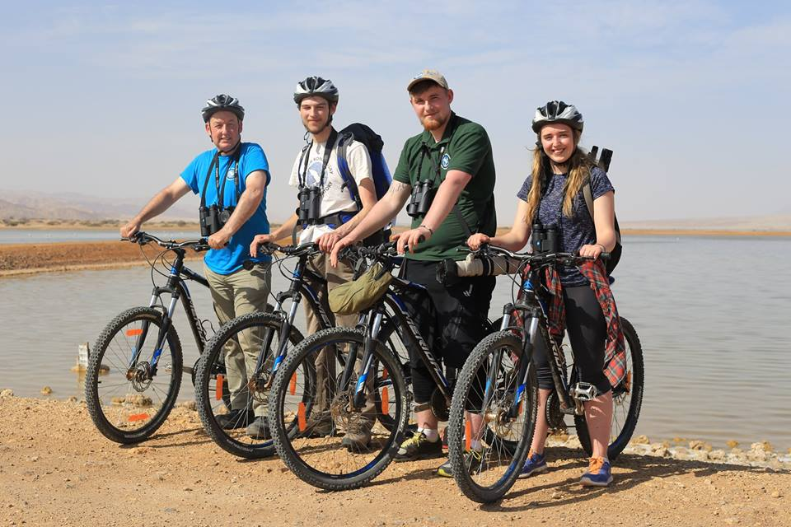
Left to right: Gary Prescott, Samuel Perfect, George Gay and Erin Taylor ©Yuval Dax
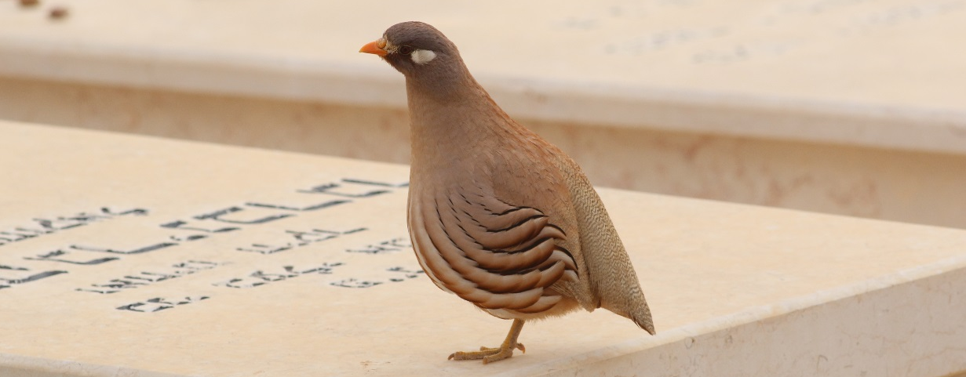
Sand Partridge ©George Gay
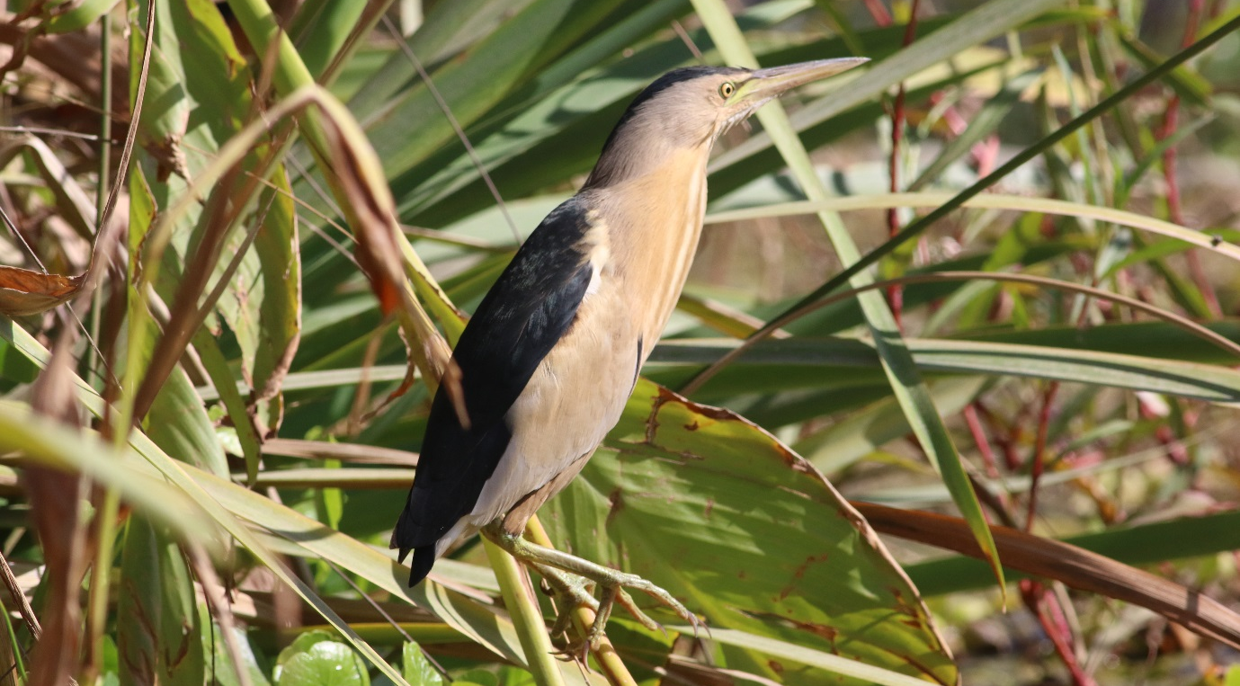
Little Bittern ©George Gay
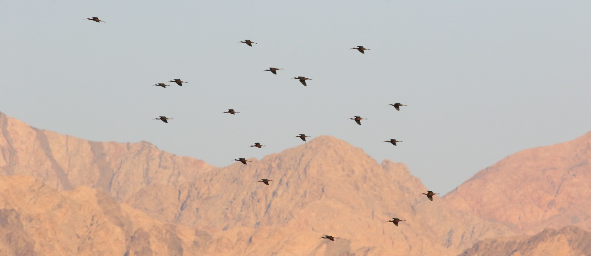
Glossy Ibises ©George Gay
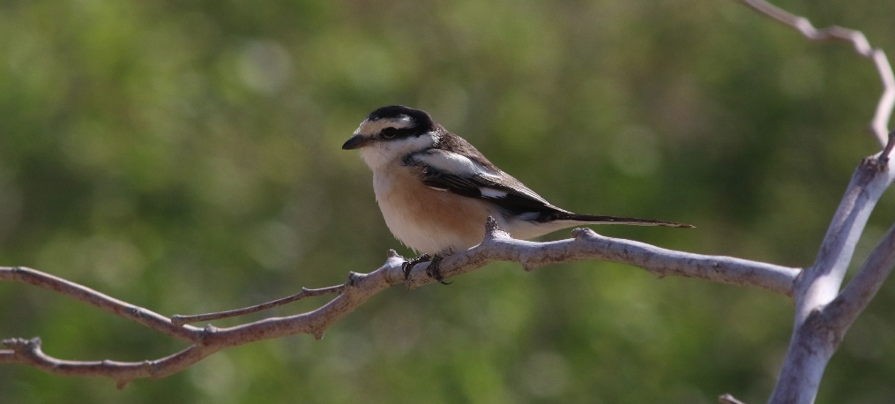
Masked Shrike ©George Gay

