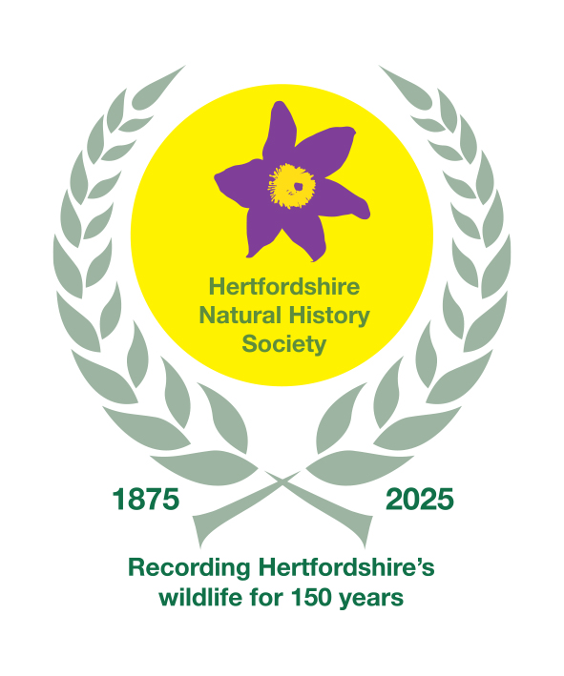
Hertfordshire Natural History Society

Privacy Policy
This privacy policy sets out how the Hertfordshire Natural History Society (and Herts Bird Club) (‘HNHS’) complies with its data protection obligations as a Data Controller. You can always access this policy through our website or by requesting it directly.
If you have any queries, then you can contact us via:
Email: secretary@hnhs.org
Address: 250 Sandridge Road, St Albans AL1 4AL
HNHS is committed to respecting the privacy of all visitors to its website. We have structured our website so that, in general, you can visit HNHS on the web without identifying yourself or disclosing any personal information. Once you choose to provide us with any information by which you can be identified, then you can be assured that it will only be used in accordance with this privacy policy.

Who we are
HNHS is a charity dedicated to the scientific study and recording of the natural history of Hertfordshire.
HNHS
Registered Charity Number Company Limited by Guarantee, Registered in England and Wales No. 218418
Registered Office: 250 Sandridge Road, St Albans, AL1 4AL
HNHS is subject to the UK General Data Protection Regulation (GDPR) and the Privacy & Electronic Communications Regulations 2003 (PECR). The Privacy Officer for the HNHS is the Hon. Secretary (contact details as above).
This policy, updated in July 2026, recognises further provisions introduced by the Data (Use and Access) Act 2025

The information we collect about you
In order to support our charitable activities in the most effective manner and to ensure that we communicate with you in the way that you prefer, we may collect and hold personal information about you in the following ways:

Personal information that you may provide to us:
Your name, address, e-mail address and other relevant information when you join HNHS, enquire about HNHS membership, provide records to a county recorder, become or express an interest in becoming a volunteer, report a sighting, make a donation, purchase goods, submit a photograph, request data or make general enquiries.
Financial information to support the processing of payment information, such as bank account details, and whether donations qualify for Gift Aid.

Personal information created through your engagement with HNHS:
Submission of a record creates data which may be classed as personal information (as an observation can identify where you were on a particular date).
Our network of county recorders may collect information relating to their interactions with you whilst carrying out their role supporting HNHS.
On our website we make use of cookies in order to provide you with the best possible user experience and to allow you to make use of certain functions. This may lead to the transfer of information classed as personal data to HNHS. For further information please see: Our policy on cookies and what we use them for.
If you subscribe to receive an email newsletter, your response to emails you receive may be logged, allowing us to determine, for example, if email is opened and if links within the email have been visited. This information is used to help assess the effectiveness of such emails so that we can improve them and may occasionally be used to send relevant further communications in response to your actions (e.g. clicking a particular link) or inactions (e.g. not opening an email), in accordance with your contact preferences. You can unsubscribe from recurring email communications at any time by emailing us secretary@hnhs.org.

Personal information received from third parties:
From time to time HNHS might undertake scientific activities with partner organisations and such activities might lead to the transfer to us of personal data.

What we may do with the information we collect
HNHS will never sell your personal data, and will only ever share it with other individuals or organisations where necessary and where guarantees as to its privacy and security have been provided.
When you interact with HNHS and have not advised us to the contrary, you are agreeing that we may use your personal information for the purposes set out in this policy. HNHS will only process your personal data where it has a lawful basis for doing so (as specified under Article 6 of the UK General Data Protection Regulation - GDPR). In most cases, the lawful basis is that processing such data is necessary for the legitimate interests of HNHS.
HNHS seeks to balance the preservation of your rights under the GDPR & the Privacy and Electronic Communications Regulations (PECR) with the HNHS’s legitimate interest in promoting and managing volunteering activities associated with the recording of the natural history of Hertfordshire. This activity is central to the achievement of our charitable objects and delivers scientific rigour to our survey endeavours. We reinforce your rights by offering you the option not to receive information linked to this purpose. If you feel your personal rights override our legitimate interests, you will have the opportunity to ask us not to use your information in such a way.

In other cases, the legal basis for processing your personal data may be:
- where you have given clear consent for us to do so for a specific purpose;
- where the processing is necessary for a contract HNHS has with you, or because you have asked us to take specific steps before entering into a contract;
- where the processing is necessary to protect someone’s life;
- where the processing is necessary for HNHS to perform a task in the public interest or for its official functions, and the task or function has a clear basis in law;
- where the processing is necessary for HNHS to otherwise comply with the law.

Where we process personal data on the basis of our legitimate interests, we do so for the following purposes:
- to manage members, volunteers, partnership relationships, and commercial interactions;
- to ensure the effectiveness and rigour associated with the operation and results of our surveys, including contacting you to validate and/or verify your data;
- to provide you with feedback on the records you have contributed to;
- to enable us periodically to send you information about our work which we think you may find interesting, using the contact channels you have indicated you prefer (you may opt out of receiving such communications at any time);
If you are under 18 years of age and wish to engage with HNHS projects or memberships then we will require permission from a parent or guardian to store and, in some cases, to use your personal data. If we obtain personal data from you whilst you are under 18, this information may remain associated with your profile when you reach the age of 18. After this point you will be able to manage your personal data preferences alone.

Justification of the Legal Basis for Processing Personal Information
- Volunteering: HNHS seeks to balance the preservation of your rights under the UK GDPR & PECR alongside HNHS’s legitimate interest in promoting and managing volunteering activities associated with the recording of natural history. This activity is central to the achievement of HNHS’s charitable objects. We reinforce data subjects’ rights by offering data subjects the opportunity not to receive information linked to this purpose.
- Trading: HNHS processes personal information in connection with the sale of products provided by HNHS to HNHS members, supporters, customers and others, entered into by way of a contract for goods. We reinforce data subjects’ rights by offering data subjects the opportunity not to receive information linked to this purpose.
- Membership: HNHS processes personal information in connection with the provision of membership services and products provided by way of a contract entered into with HNHS members and/or those individuals purchasing for themselves or for other parties. We reinforce data subjects’ rights by offering data subjects the opportunity not to receive information linked to this purpose.
- Donations: HNHS seeks to balance the preservation of your rights under the GDPR & PECR alongside the HNHS’s legitimate interest in seeking support for our charitable objectives the scientific study of the natural history of Hertfordshire.
- General Information: HNHS may acquire and retain personal information in order to provide general information, education and knowledge about the projects, services and resourcing of the charity. HNHS balances this legitimate interest with the rights of data subjects under the UK GDPR & PECR. We reinforce data subjects’ rights by offering data subjects the opportunity not to receive information linked to these general purposes.

How we store your information
We are committed to ensuring that your information is secure. In order to prevent unauthorised access or disclosure we have put in place suitable physical, electronic and managerial procedures to safeguard and secure the information we collect. We ensure that encryption is used where appropriate.
The HNHS enables individuals who wish to do so to pay their membership subscriptions through its website (www.hnhs.org). Credit and debit card transactions using our website are conducted through the agency of PayPal (Europe) S.à.r.l. et Cie, S.C.A and Stripe Payments Europe Ltd. Both PayPal and Stripe are certified to the relevant PCI compliance standards to ensure the security of customer credit card data, and safely handle payments made to us using PCI compliant payment services.
The majority of our operations are based in the UK and we store the bulk of our data within the UK and member states of the European Union. Some organisations that provide services to us may transfer personal data outside of the EEA; we will only allow them to do this where those organisations assure us that they comply with a regulatory environment that is compatible with the GDPR.
We will only store your personal information for as long as it is required for the purposes it was collected for. How long information will be stored for depends on the nature of the information collected and what it is being used for. We will undertake regular reviews of the personal information that we hold and will delete personal information that is no longer required to be held (whilst maintaining a record of any preferences expressed by you not to be contacted).

Your rights
Whilst we collect and process personal information in order to undertake our work, HNHS is committed to protecting your rights. Here we set out a brief description of them.
- You have the right to confirmation as to whether or not we have your personal information and, if we do, the right to obtain a copy of the personal information we hold (this is known as a Subject Access Request). Should you wish to make such a request, please contact us as detailed above.
- You have the right to request that we remove some or all of your personal information (though this may not apply where it is necessary for us to continue to use the data for a lawful reason). If you wish to make such a request, please contact us as detailed above.
- You have the right to have any inaccurate personal information corrected; and/or to specify some of the purposes for which we may contact you; and/or to specify some of the channels by which we may contact you. You can do this at any time, by contacting us directly as detailed above.
- You have the right under the Data (Use and Access) Act 2025 to make a direct, formal complaint to us about the way we use your data. Complaints should normally be submitted using our standard proforma. If you are unhappy our response, you may escalate it to UK Information Commissioner’s Office which regulates and enforces data protection law Details of how to do this can be found at www.ico.org.uk.

Young people
HNHS wishes to support the energy, enthusiasm and philanthropic spirit that young people demonstrate as they engage with the natural world.
On occasion we might offer the opportunity for young people to engage in events or competitions as part of their involvement with HNHS. Similarly, young people might actively engage in interactive participation with HNHS in various social media settings. From time to time, through our work with schools, youth groups we might offer the opportunity for young people to engage in volunteering projects in support of HNHS’s work.
If, in connection with any of these types of activities, HNHS publishes personal information about a person under the age of 18, we will limit that information to a picture, the first name, surname and age of that person.
Parental permission: If a person is under 18 years of age then we will need permission from a parent or guardian for them to submit a record, share a picture, photo or story with us.
In order to donate to HNHS or to purchase goods or services from us you need to be over 18 years of age.

Links to external sites
Please note that our website may contain links to enable you to visit other websites of interest easily. However, once you have used these links to leave our site you should note that we cannot be responsible for the protection and privacy of any information which you provide whilst visiting such sites, which are not governed by this privacy policy. You should exercise caution and look at the privacy policy applicable to the website in question.

31st July 2026

